|  |
| --- |
| Name: Hembadura De Silva |
| Student Reference Number: 10707162 |



|  |  |  |
| --- | --- | --- |
| Module Code: PUSL2003 | Module Name: Integrating Project | |
| Coursework Title: Project Proposal | | |
| Deadline Date: Saturday, 31 October 2020, 11:30 AM | | Member of staff responsible for coursework:  Mr. S.M. Upulanka Premasiri |
| Programme: Software Engineering | | |
| Please note that University Academic Regulations are available under Rules and Regulations on the University website [www.plymouth.ac.uk/studenthandbook](http://www.plymouth.ac.uk/studenthandbook). | | |
| Group work: please list all names of all participants formally associated with this work and state whether the work was undertaken alone or as part of a team. Please note you may be required to identify individual responsibility for component parts.  Hembadura De Silva – 10707162  Arumadura De Silva - 10707163  Galeena Ariyasinghe - 10707132  Chathurma Wijesinghe - 10707419  Pasindu Kurukulasooriya - 10707248  ***We confirm that we have read and understood the Plymouth University regulations relating to Assessment Offences and that we are aware of the possible penalties for any breach of these regulations. We confirm that this is the independent work of the group.***  Signed on behalf of the group: | | |
| Individual assignment: ***I confirm that I have read and understood the Plymouth University regulations relating to Assessment Offences and that I am aware of the possible penalties for any breach of these regulations. I confirm that this is my own independent work.***  Signed : | | |
| Use of translation software: failure to declare that translation software or a similar writing aid has been used will be treated as an assessment offence.  I *have used/not used translation software.  If used, please state name of software………………………………………………………………… | | |
| **Overall mark _____% Assessors Initials ______ Date_________** | | |

*Please delete as appropriateSci/ps/d:/students/cwkfrontcover/2013/14



**PUSL2003 Integrating Project**

**Technical Specification 2020/21**

### Group Name/Number:

Group 27

Members:

|  |  |  |
| --- | --- | --- |
| ID | Name | Degree Program (SE/CN/CS) |
| 10707162 | Hembadura De Silva | SE |
| 10707163 | Arumadura De Silva | SE |
| 10707419 | Chathurma Wijesinghe | SE |
| 10707248 | Pasindu Kurukulasooriya | SE |
| 10707132 | Galeena Ariyasinghe | SE |
|  |  |  |

**ABSTRACT**

The concept of Learning Management System has been used in number of universities, collages and educational institutions worldwide. It provides an interface to connect with students and teachers instead of traditional classroom. Developing a Learning Management System accompanied by advances new features is our main objective. When bearing in mind to early ages, first LMS was designed in 90s nevertheless it was criticized. Over the past few decades this LMS concept has being developing so far.

When considering the System Analysis, fact gathering carries a huge role. Queries, Google Forums, Online Conferences, Remote Interviews assist us to understand the current system and its drawbacks. Ambiguity GUI designs, no fix UX for mobile devices, no authentication for 3rd parties are major drawbacks. Using Single Sign On, attractive GUIs, mixed learning approaches drive out from above drawbacks.

Requirement Specifications can be divided into small fragments. Live conferencing, chat ability, payment ability are main functional requirements. Being user-friendly, adaptability, maintainability are key non-functional requirements. Under the performances, recommended RAM capacity should be 4GB in a PC and 3 GB for mobile devices & will be supported iOS and upwards windows 7. Password authentication, domain-based registrations, safe login screen, SSL protocol have facilitated under the security requirements. As hardware parts users need a device like mobile phone, computer, tablet etc., browser and the internet access.

Under the feasibility study this application should be economical feasible in both qualitative and quantitative ways. Users should have a good knowledge in IT is a operational issue. Giving one-hour training session about the application will be a solution. When entering details to the Login form if PC or Mobile Phone gets off all the entered information will get erased can consider as technical issue, As a solution Entered information can be saved temporary in the database. Not only that the application must me feasible in organizationally too.

TABLE OF CONTENTS

ABSTRACT

LIST OF FIGURES

LIST OF TABLES

CHAPTER

1. INTRODUCTION
   1. Introduction
   2. Definition of the problem
   3. Project Objectives
   4. Scope of the project
   5. Summary
2. SYSTEM ANALYSIS
   1. Background Research (Current system)
   2. Facts gathering techniques
   3. Overall use case diagram for the current system
   4. Drawbacks of the current system
   5. Summary
3. REQUIREMENT SPECIFICATION
   1. Functional requirements
   2. Non-functional requirements
   3. Performance requirements
   4. Security requirements
   5. Hardware requirements
   6. Networking requirements (optional)
   7. Safety requirements (optional)
   8. Summary
4. FEASIBILITY STUDY
   1. Economic feasibility
   2. Operational feasibility
   3. Technical feasibility
   4. Organizational feasibility
   5. Outline budget
   6. Summary
5. SYSTEM ARCHITECTURE
   1. Class diagram of the proposed system
   2. Entity Relationship Diagram of the Proposed System
   3. High-level architecture diagram
   4. Network diagram (optional)
6. DEVELOPMENT TOOLS AND TECHNOLOGY
   1. Development methodology
   2. Programming languages and tools.
   3. Third Party Components and Libraries. (Optional)
   4. Algorithms
   5. Hardware tools (optional)
   6. Summary
7. DISCUSSION
8. REFERENCES
9. TEAM PLAN & RESPONSIBILITIES

LIST OF FIGURES

Figures Page No

Fig. 2.21 Graphical rep. after obtaining results of the questioner about LMS

Fig. 2.22 Graphical rep. obtaining results about adding new features

LIST OF TABLES

Table Caption Page No

3.11 Functional Requirements

3.21 Non-functional Requirements

4.11 Economic Feasibility

4.21 Operational Feasibility (Operational issues & solutions)

4.31 Technical Feasibility (Technical issues & solutions)

1. INTRODUCTION
   1. Introduction

The main objective of our project is to facilitate students who are stuck at home and those who unable to attend schools or tuition classes due to the Covid19 pandemic. We hope to develop a learning management system as a mobile application which is easy to use by everyone. The concept of a LMS is not new today. But there are still many areas that need to be considered. The aim of our project is to introduce a new Learning Management System that goes beyond the features of an existing Learning Management System. If we consider the features of our application, it may provide an opportunity to communicate both students and teachers.

From the student’s side,   
• Student can sign up & sign in, pay fees for the course, download videos, download assignments, papers, watch videos, ask questions, upload answers for assignments

From the teacher’s side,   
• Teacher can sign up & sign in, upload videos, send messages to parents (whether the student has watched videos or not), upload assignment question, papers etc. ,check how many viewers and who has viewed the video, answer questions asked by the students, live video conferencing & video converter are some special features that we hope to add.

* 1. Definition of the project

Actually, the main reason of this application is this dangerous situation with the corona virus. we have to keep safety first now that’s why we got this idea to make this project. In education, work or something important thing, if we work in online platform, it is better option. So we thought we can give the mobile app for our students and teachers. Now the education works are standstill, we think that they can be done as before without any problem through this application. In this situation in the main A/l and O/l students, they can’t attend their classes and if physically attend the classes sometimes they are in danger. It’s hard for them, their parents and teachers. Finally, we thought this is a best solution for this problem.

* 1. Objectives of the project
* To connect teacher and student via mobile app.
* To give out the facility to view and download lessons, videos, assignments and papers.
* To give out the facility to teach from home.
* To enhance learning process and distance education.
* To create a virtual classroom
* Online payment service
  1. Scope of the project
* **Description of the work**In our project we want to create virtual class room for students and teachers. our stakeholders are tuition teachers and students. Actually all things that happened in typical classroom must happen through this application. We offer video conferencing, upload and download assignments, papers, notes, videos, chatting facility and payment facility. Mainly we have given them the opportunity to study without any distance problem.
* **Deliverables**

Our client gets these deliverables. they are,

1. Online video conferencing
2. Private chatting and chat option for asking questions and answering
3. Download and watch lessons, assignments, papers, videos and upload option for teacher
4. Payment option (student can pay their lessons and teacher can get their money through our application)
5. Sign up & sign in options for both of them
6. Can watch who attend the class or not
7. Send message to student’s parents

* **Constraints**

We have planned create a mobile web application for tuition students and teachers. Actually this app is available from both mobile and web browsers. So mobile web applications use web technologies and are not limited to the underlying platform for deployment.

* **Inclusions / exclusions**

Here we have done a good look at the existing online lms and video conferencing apps like zoom, Microsoft teams. There we saw that already have video conferencing, chatting, download and upload option and signup & sign in option. But we thought existing features are required anyway. that’s why We don’t remove any existing feature. But we have planned add to new features for our mobile web application. They are,

1. Teacher can watch who is attend the class or who not attend the class and can see total number of student attending class
2. Payment option

Also we have done the research to know what are the best features and what are the people think best for it. we used to google form for research.

* **Assumptions**

In fact, the main premise we have built is to make a more perfect online education platform than the existing online educational platforms for our stakeholders. So we assume this is best and easy-to-use product for them. Because our mobile web application has more good features and we assumed stakeholders definitely like it. We thought actually in this pandemic situation, tuition students and teachers can engage any distance issue through our application and not only is education happening, teachers can also earn their money at home.

1.5 Summery

In this our mobile web application (online education platform) tuition students and teachers can do their works without any problem. So we took existing features and we put our new features to our app. our features are download, watch and upload lessons videos assignments papers also teacher can upload them, sign up & sign in, video conferencing, chatting, payment option, send message to parents and total count of student attending class. Our stakeholder can get these deliverables. And users definitely want mobile and web browser for access this. Finally, we give the opportunity to do their educational works without any distance issue or unsafe condition.

**02- SYSTEM ANALYSIS**

**2.1 Background Research**

With the advancement of technology in these days, learning inside a classroom is not the only way to study. Because of the rapid development of Information Technology & internet- based things, e-learning, distance learning, mobile learning has emerged. So, anyone can involve in their studies at anywhere & any time.

As an example, when we consider about a traditional classroom, it’s full with uniformity and if we talk about the students, the capacity of each student is different. Some students get more time to understand. Moreover, the engagement between students and teachers are less. Nevertheless, sometimes they are not focusing. But using LMS reduces those problems, not only that but also to continue studies even on pandemics like we face on these days.

What is LMS? Learning Management System (LMS) is a concept which is integrating with multiple media, multiple languages and multiple technologies to present, create, evaluate and fulfill educational purposes and frequently they are rich with multiple tools and functions to enable modern learning environment. LMS creates an interaction between the communication devices and participants by providing attractive interfaces.

**Throwback to initiating stage – current stage of LMSs**

In 90s, the first LMS was innovated along with the first web browsers, but it was criticized as they believe these technologies are harmful. Before it migrates to the web era, LMS was designed to serve individual institution Learning requirements only.

Over the past few years Learning Management systems were designed using different technologies like cloud computing, web programming languages, java, php, MySQL, Java Script…etc) and has given more interest in users preferences.

When we talk about the current Learning Management Systems, they are going under the Global Standards for LTI and APIs. Inside the LMS granting access to content and materials working on LMS environment. If we consider about current LMS most of them are web based.

Current LMS organizes as courses, courses divided into modules, each module contains lessons. LMS functionalities are Students & lecturers login, Face-to-face learning, e-book libraries, automatically generated tests, chats, forums, blogs, video blogs, watching videos, assignment submissions, Calendar, ask questions.

**2.2 Fact gathering technics**

One of the most important steps in analysis phase is requirement gathering. We have used suitable fact gathering technics to develop and implement the current system.

1. Understanding the background & record view

We Studied Information related to the current system which is already available as documents, articles, records and published materials (magazines, papers). It is one of the fastest and independent ways to gather information and used to prepare further questionnaires.

1. Queries

Taken as a whole, in society there are students those who have used LMS and those who haven’t. taking their ideas and responds is much more important. For that, considering the current situation in our country we are unable to conduct face-to-face interviews or observations. So, we created and shared a google forum as a questionnaire. We were able to get an idea and a feedback about the current system and what they thought about adding new features and was able to get their ideas too.

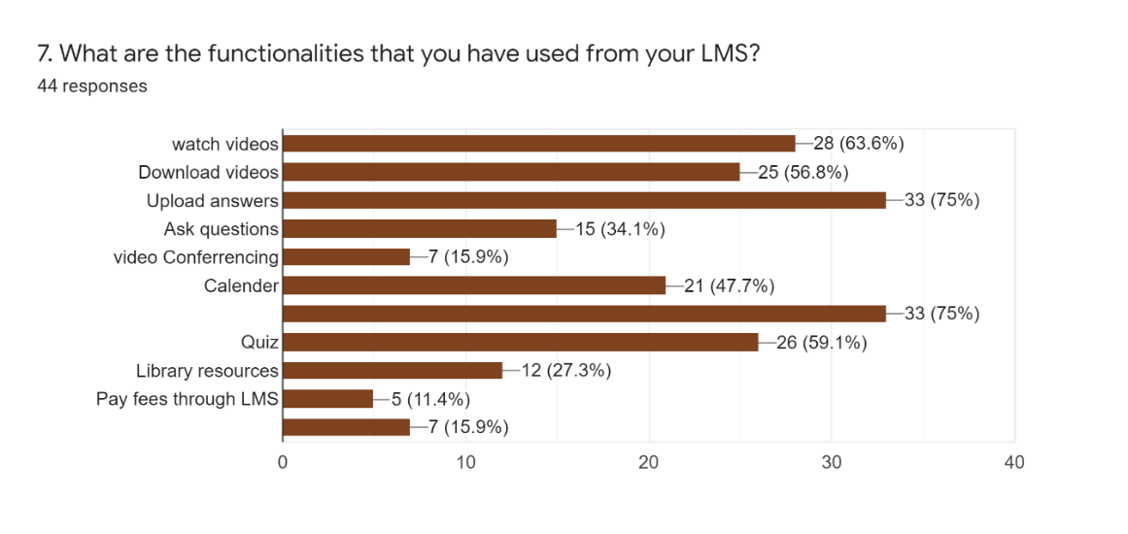

Figure 2.21 Graphical representation after obtaining the results of the questioner about LMS

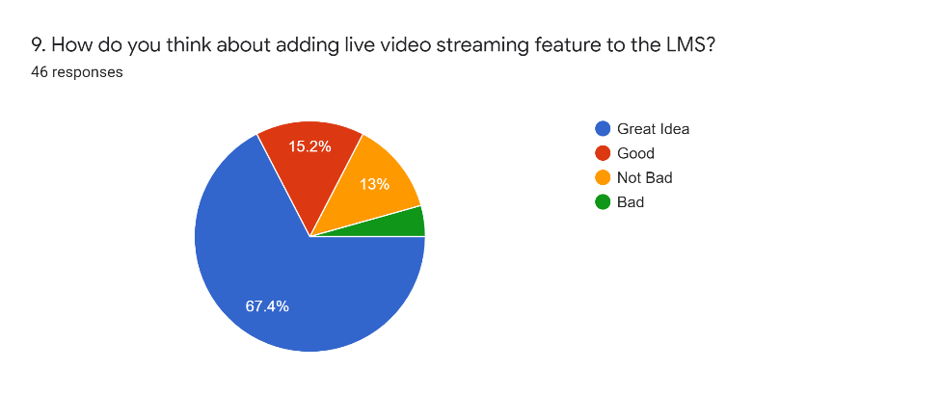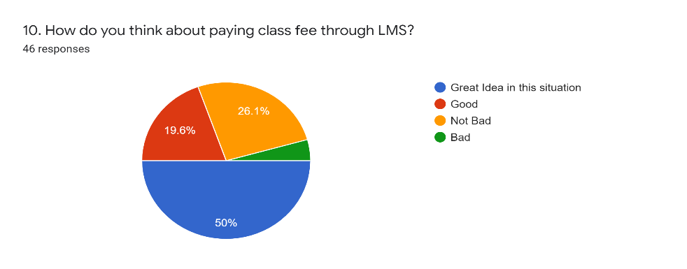We aware our audience about new feature that we are going to add and their opinion.

Figure 2.22 Graphical representation after obtaining results regarding to adding new features

1. Online Conferences

The requirement of creating new LMS with advance features was given by a English Lecturer Mr. Pathum Wickramasinghe. He and his students face lots of troubles in Learning and studying with this COVID situation. Not only that he faces troubles when charging class fees. Eventually he wanted a solution for this matter. So, he brought this matter to us and we are trying to help by designing new LMS. So, every time we connect with him using video conferences and knowing his requirements.

1. Remote interviews

We hold remote interviews with students & clients.

**2.4 Drawback of current system**

Issues of current system, how they overcome, Manage & find solutions

Usability related issues- A LMS should be easy to use everyone. It should not be a mystery. There are lot of people with inexperienced with IT knowledge.

1. Ambiguity GUI designs

When we are using LMS we are dealing with UIs. If they seem difficult, users will be confusing.

` solution: they are creating attractive GUIs. Not only that many users both lecturers and students are not good in IT so, now they always provide user friendly user interfaces and icons

1. Glitches in accessing LMS

When we try to access our software, it should be bringing us step by step closer to achieve our purpose. No one need to waste time.

1. Inability to connect with 3rd parties

The current Learning Management Systems are not fully with all the features. So, users have to work with other third-party tools. (this is one reason; we need to implement new LMS with all features)

Solution : A mixed learning approach (combine with traditional face-to-face instruction with self-paced learning) And using standard compliant like (SCORM, AICC and xAPI/ Tin Can) and non-standard compliant(live streaming, uploading documents) .

1. Another major drawback of LMS is there is no fixed UX for mobile phones. Today mobile phones ahead than other devices like desktop computers, laptops. So, it is essential to access their content using mobile devices. That’s why LMS needs fixed, adaptive, fluid, responsive layouts.
2. After a while student demotivated an lose their interest in using LMS.

Solution : For student’s demotivation after sometime, LMS provides bridges to connect with social media and with other technical tools. It helps to make this journey attractive. LMS provides an interface to create users own content

1. Using many systems to maintain and tracking user data. Sometime the relevant data can be stored in multiple locations. So, users have to sign in with different systems.

`A LMS with wide APIs and Integrating libraries let to exchange data with other integrating organization’s third party HRIS, HRMS, databases. Data from different platforms can be access using single LMS. Single sign on, SSO avoid login multiple systems. No need of remembering multiple user names & passwords. One student requires one credential to access various facilities.

Ex: University of Plymouth LMS

**Disadvantages**

Student’s Side

1. Even if the education is done using e-learning, when you coming to the industry, they require physical skills which you can’t learn online. People can face exams online, but when they come up with real life scenario, they need physical skills and ability.

1. The tunnel effect- another drawback of learning through LMS is student’s tunnel vision. They don’t know about other learning opportunities outside the LMS. They don’t know the competition outside world.
2. Physical training can’t be fully replaced by Online training.

Many researches point out that it takes more 40%-60% time to e-learning than traditional classroom learning. And there’s a big possibility of drifting off from their learning while e-learning

**Administrative Side**

1. Cost for implementation, set up, purchasing, maintaining & security is high

**Lecturers Side**

1. Most of lecturers don’t have better knowledge in IT. Somehow a bit of IT knowledge needs to use effectively.
2. Another challenge is to create learning activities for students using lecturer’s technical styles and capacities.

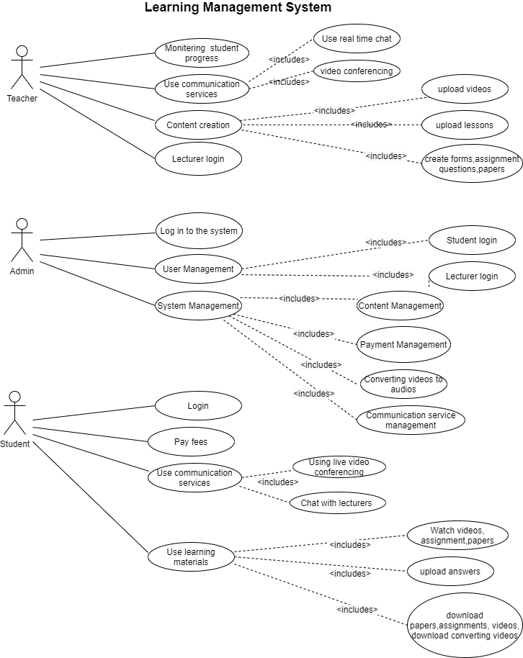Use case diagram

**2.5 Summary**

This chapter tries to evolve you the background of the current Learning Management Systems. How it has evolved over the past years. Furthermore, doing an analyze before the project design and implementation is very essential. By that we can get an idea about how users involve with current system, issues that arise when using LMS (Usability issues, technical issues), Disadvantages & how developers have managed them.

## CHAPTER-03 REQUIREMENT SPECIFICATION

## 3.1 Functional Requirements.

|  |  |
| --- | --- |
| **ID** | **Requirement** |
| REQ 1 | Conferencing |
| REQ 1.1 | Audio Conferencing |
| REQ 1.2 | Video Conferencing |
| REQ 1.3 | Recording Ability |
| REQ 2 | Shall be able to Pay tuition fees online |
| REQ 3 | Chat ability |
| REQ 3.1 | Should be able to ask and answer questions while tutoring |
| REQ 3.2 | Should be able to chat with colleges privately |
| REQ 4 | Should be able to schedule new classes |
| REQ 5 | Ability to download / upload |
| REQ 5.1 | Class recordings |
| REQ 5.2 | Assignments |
| REQ 5.3 | Class Notes / Papers |
| REQ 6 | Message sending |
| REQ 6.1 | Send parents a message (whether the student have watched/attend the class or not) |
| REQ 6.2 | Send message/email to students when upload a video / organize a class |
| REQ 7 | Both tutor/ students fill an application to register |
| REQ 8 | Tutor should be able to check no of viewers who viewed the uploaded things |
| REQ 9 | Ability to convert video (video to audio) |

Table 3.1

## Non – Functional Requirements.

|  |  |
| --- | --- |
| **ID** | **Requirement** |
| REQ 1 | User Friendly |
| REQ 2 | Provide Security |
| REQ 3 | Maintainability |
| REQ 4 | Adaptability |
| REQ 5 | Installablity |
| REQ 6 | Replaceability |
| REQ 7 | Reusability |
| REQ 8 | Flexibility |

Table 3.21

## Performance Requirements.

1. Recommended RAM capacity should be 4GB (in a PC).
2. Minimum RAM capacity should be 3GB (in a mobile phone).
3. To download the application minimum required ROM should be 32GB (to android phone via ‘google playstore’).
4. To run this application recommends 1.5 mbps internet speed.
5. Need minimum of 32bit operating system.
6. The recommended processor requirement is Dual core 2Ghz or higher (Intel i3/i5/i7 or AMD equivalent).
7. Supported OS windows 7 and upwards.
8. Supported browsers Internet Explorer and Google Chrome.
9. Recommended bandwidth for tutors for online classes:

* For 1: 1 Video conferencing:

1. 600kbps(up/down) for high quality video.
2. 1.2mbps (up/down) for 720p HD video.
3. Receiving 1080p HD video requires 1.8mbps (up/down).
4. Sending 1080p HD video requires 1.8mbps (up/down).

* For group video conferencing:

1. 800kbps/1.0mbps (up/down) for high quality video.
2. Receiving 1080p HD video requires 2.5mbps(up/down).
3. Sending 1080p HD video requires 3.0mbps (up/down).

* For gallery view and/or 720p HD video 1.5mbps (up/down).
* For screen sharing only (no video thumbnail) 50-70kbps.
* For screen sharing with video thumbnail 50-150kbps.
* For audio VoIP 60-80kbps.
* For online classes from phone 60-100kbps.

1. Recommended bandwidth for students for online classes:

* For 1:1 video conferencing:

1. 600kbps (down) for high quality video and 1.2mbps(down) for HD video.
2. For screen sharing only (without video thumbnail) 50-75kbps(down).
3. For screen sharing with video thumbnail 50-150kbps(down).
4. For audio VoIP 60-80kbps(down).

## 3.4 Security Requirements.

1. Students’ details are only visible to the relevant Tutor.
2. Tutor’s details are only visible to his/her students.
3. Facilitate and maintained by admin only.
4. Both the student and the tutor must fill a form including their details when registering.
5. Maintain user Privacy (Can be login only using email and password.)
6. Password authentication.
7. Domain-based registrations.
8. Anti-virus.
9. Texts sent to the tutor cannot be deleted.

**When Doing Online Payments.**

1. Safe login screen.
2. SSL Protocol.

**When Doing Online Video Conferencing.**

1. Be wary of unknown emails.
2. Disable file transfer feature.
3. Notify the users when the meeting is being recorded.
4. Utilize waiting rooms or lobbies.
5. Not allowing participants to screen share by default. (Must get permission from the meeting organizer.)

## 3.5 Hardware Requirements.

1. A Phone / Computer / Laptop

* Note: As this is a mobile web application if using a PC the user should download and install ‘Bluestacks’ application in their PC.

1. Browser
2. Internet access
3. A Modem / Modem + Telephone Line
4. ISP (Internet Service Provider)

## Safety Requirements.

1. Able to increase and decrease the sound as it might harm our ears.
2. Able to adjust the video’s brightness as it might harm our eyes.
3. Able to select an audio method (speaker, earphone) and able to adjust sound separately for different methods. So, the user can choose one which is more comfortable to his/her ears.

## Summary.

Our proposed application has functional requirements like video conferencing, online payments, chatting ability etc. Reusability, installability, maintainability are some non-functional requirements. As performance requirements need 32bit OS, minimum 4gb RAM, 1.5mbps internet speed etc. Be wary of unknown emails, SSL protocol, password authentication etc are under security requirements. As hardware requirements need a phone, internet access, browser. This application will allow to adjust brightness and sound as safety requirements.

## CHAPTER 04- FEASIBILITY STUDY

## 4.1 Economic Feasibility

|  |  |  |
| --- | --- | --- |
| **Type** | **Potential Costs** | **Potential Benefits** |
| **Quantitative** | Hardware upgrades.  Software upgrades.  Software licensing fees.  Data conversion costs. | Reduced data analyzing time.  Reduction in inventory.  Reduction in IT costs. |
| **Qualitative** | User training. | Higher quality products.  Improved customer service.  Reduce the risk of traditional methods.  Increased brand recognition. |

Table 4.11

As our application is using Hardware like Processor, Hard Drive, RAM, Camera, Microphone and Speakers sometimes we may need to upgrade our Hardware. For an example we may need to upgrade our 4GB RAM into 8GB RAM in order to run the Android Studio Application faster. We may need to upgrade our Windows OS. As we are upgrading our OS and MS office application, we may need to pay a licensing fee. As we our using Google Forms as our requirement gathering technique, we reduced the data analyzing time. We clearly identified what we need the most to build up this application and listed down them and didn’t add any extra needs. As we are using many open source software, we reduced our IT costs. As some end users may not be familiar with the technology and English language, we planned to do a user training session to our client and selected students. We are planning to improve customer service and give a higher quality product. And as we are using ‘scrum’, we hope to modify it in our way so it will reduce the risk of traditional methods. We hope to partner with influencers to create content in order to increase our brand recognition.

## Operational Feasibility

|  |  |
| --- | --- |
| **Operational Issues** | **Support Issues** |
| End users must have a good knowledge in English. | Giving a user manual about all its interfaces. |
| Internet connection is required. | Selected tutors and students will get one-hour training session about the application. |
| Credit / Debit card is required to make the payments. | Selected tutors and students will get a 15mins session about doing online payments in partnership with a selected bank. |
| Should have a suitable PC or a Mobile phone to download and run this application. | End users will provide with user manuals and tutorials. |

## Table 4.21

When the user starts operating the system the user may come up with several difficulties like ‘not familiar with English language, internet connection problems, how to do online payments and is their PC or Mobile Phone is capable of running this application. For less familiarity with the technology, English language and the minimum requirements needed to run this application, end users will provide with user manuals about all the interfaces and tutorials. For internet connection problems and online payment problems we hope to do a training session.

## Technical Feasibility

|  |  |  |
| --- | --- | --- |
| **Technology Issues** | **Solution** | **Market Issues** |
| When entering details to the Login form if PC or Mobile Phone gets off all the entered information will get erased. | Entered information will be saved temporary in the database. | 3rd party database tools are supported. |
| The updating process requires Internet, when updating if the Internet goes down updating process will go down. | The process will be only paused, will not get canceled. So, the user can update later. | 3rd party operating systems are capable of using the application. |
| When doing online payments if the card has expired the user will not be able to make the payments. | The user will be able to contact the bank through this application and ask for a solution. | Capable of running in Android. |
| When in a live video conference if WIFI disabled the user will not be able to attend the class. | Have the recording ability and uploading the recorded video. So, the student can watch it later. |  |

## Table 4.31

As our application required Internet, if the internet goes down the user will not be able to attend the class and will not be able to update the application. When updating the update will only get paused and not gets cancelled. As this application have recording ability and uploading ability the user can download and watch the recording. If the PC or Mobile Phone gets off when filling the login form our database will always have a temporary backup so the user can continue from where he/she has stopped. When doing online payments as credit/debit cards are needed, if the card has expired the user cannot proceed. So, he/she can contact the bank by using this application and ask for a solution.

## Organizational Feasibility

* The tutor must have the ability to train the students to use the application.
* The tutor must encourage and guide the students to do online payments.

## 4.5 Outline Budget

* If DON’T have a PC or a Mobile Phone both the student and the tutor must buy a PC or a Mobile Phone.
* Mobile Phone (Brand new) – Min Rs.20,600 (Samsung Galaxy M01)
* Mobile Phone (Used) – Min Rs.15,000
* Laptop (Brand New) – Min Rs.56,200 (Lenovo IP330)
* Laptop (Used) – Min Rs.26,000
* Desktop Computer (Brand new) – Min Rs.40,000
* Desktop Computer (Used) – Min Rs.24,300
* For Internet Access (using data cards via Mobile Phone).
* Sim Card – Rs.100
* For video call (6 hours) – Rs.100
* For Internet Access (using a Router)

**Dialog 4G**

* Router with connection – Rs.3990
* Package Per Day – 1GB (Any Time) – Rs.40
* Work and learn package per month – 35GB (Any Time) – Rs.495

**SLT Broadband**

* Router with Sim card – Rs.3500
* Package Per Month – 36GB (Day Time) 54GB (Nighttime) – Rs.1490
* If do not have a Credit or Debit card the end user must get it from the relevant bank to do the online payments.
* Credit Card – Mostly given free from the banks, the bank will charge a credit card fee yearly (the fee differs from bank to bank).
* Debit Card – Mostly given free from the banks, if charged that is <=500.

## Summary

Our application has costs, benefits like user training, reduced IT costs etc. When operating users may have language, internet problems therefore we’ll have training sessions etc. We’ll have market issues like 3rd-party database tools supported etc. If internet disabled user cannot do many things in this application, so we have solutions like recording etc. Organizationally tutor is responsible for guiding students. Estimated minimum budget for the user is 20000.